Police Sport UK
10 Mile Road Race Championships 2019
Wednesday 4th September 2019
MOD Lyneham, Wiltshire
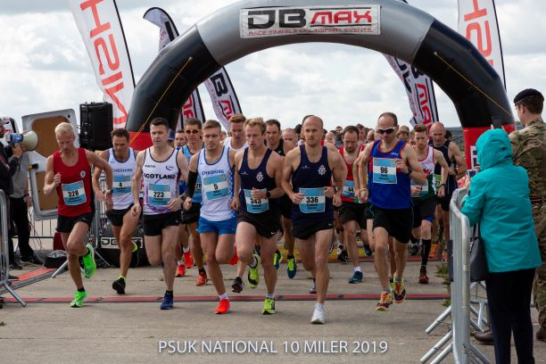
The 2019 Police Sport UK 10 Mile Road Race Championships were organised and hosted by Wiltshire Police on Wednesday 4th September 2019 within the grounds of MOD Lyneham.
The course , a two lap course within the grounds of the MOD base was describe as 'flat'. A total of 320 police staff completed the race.
The weather was good, but windy.
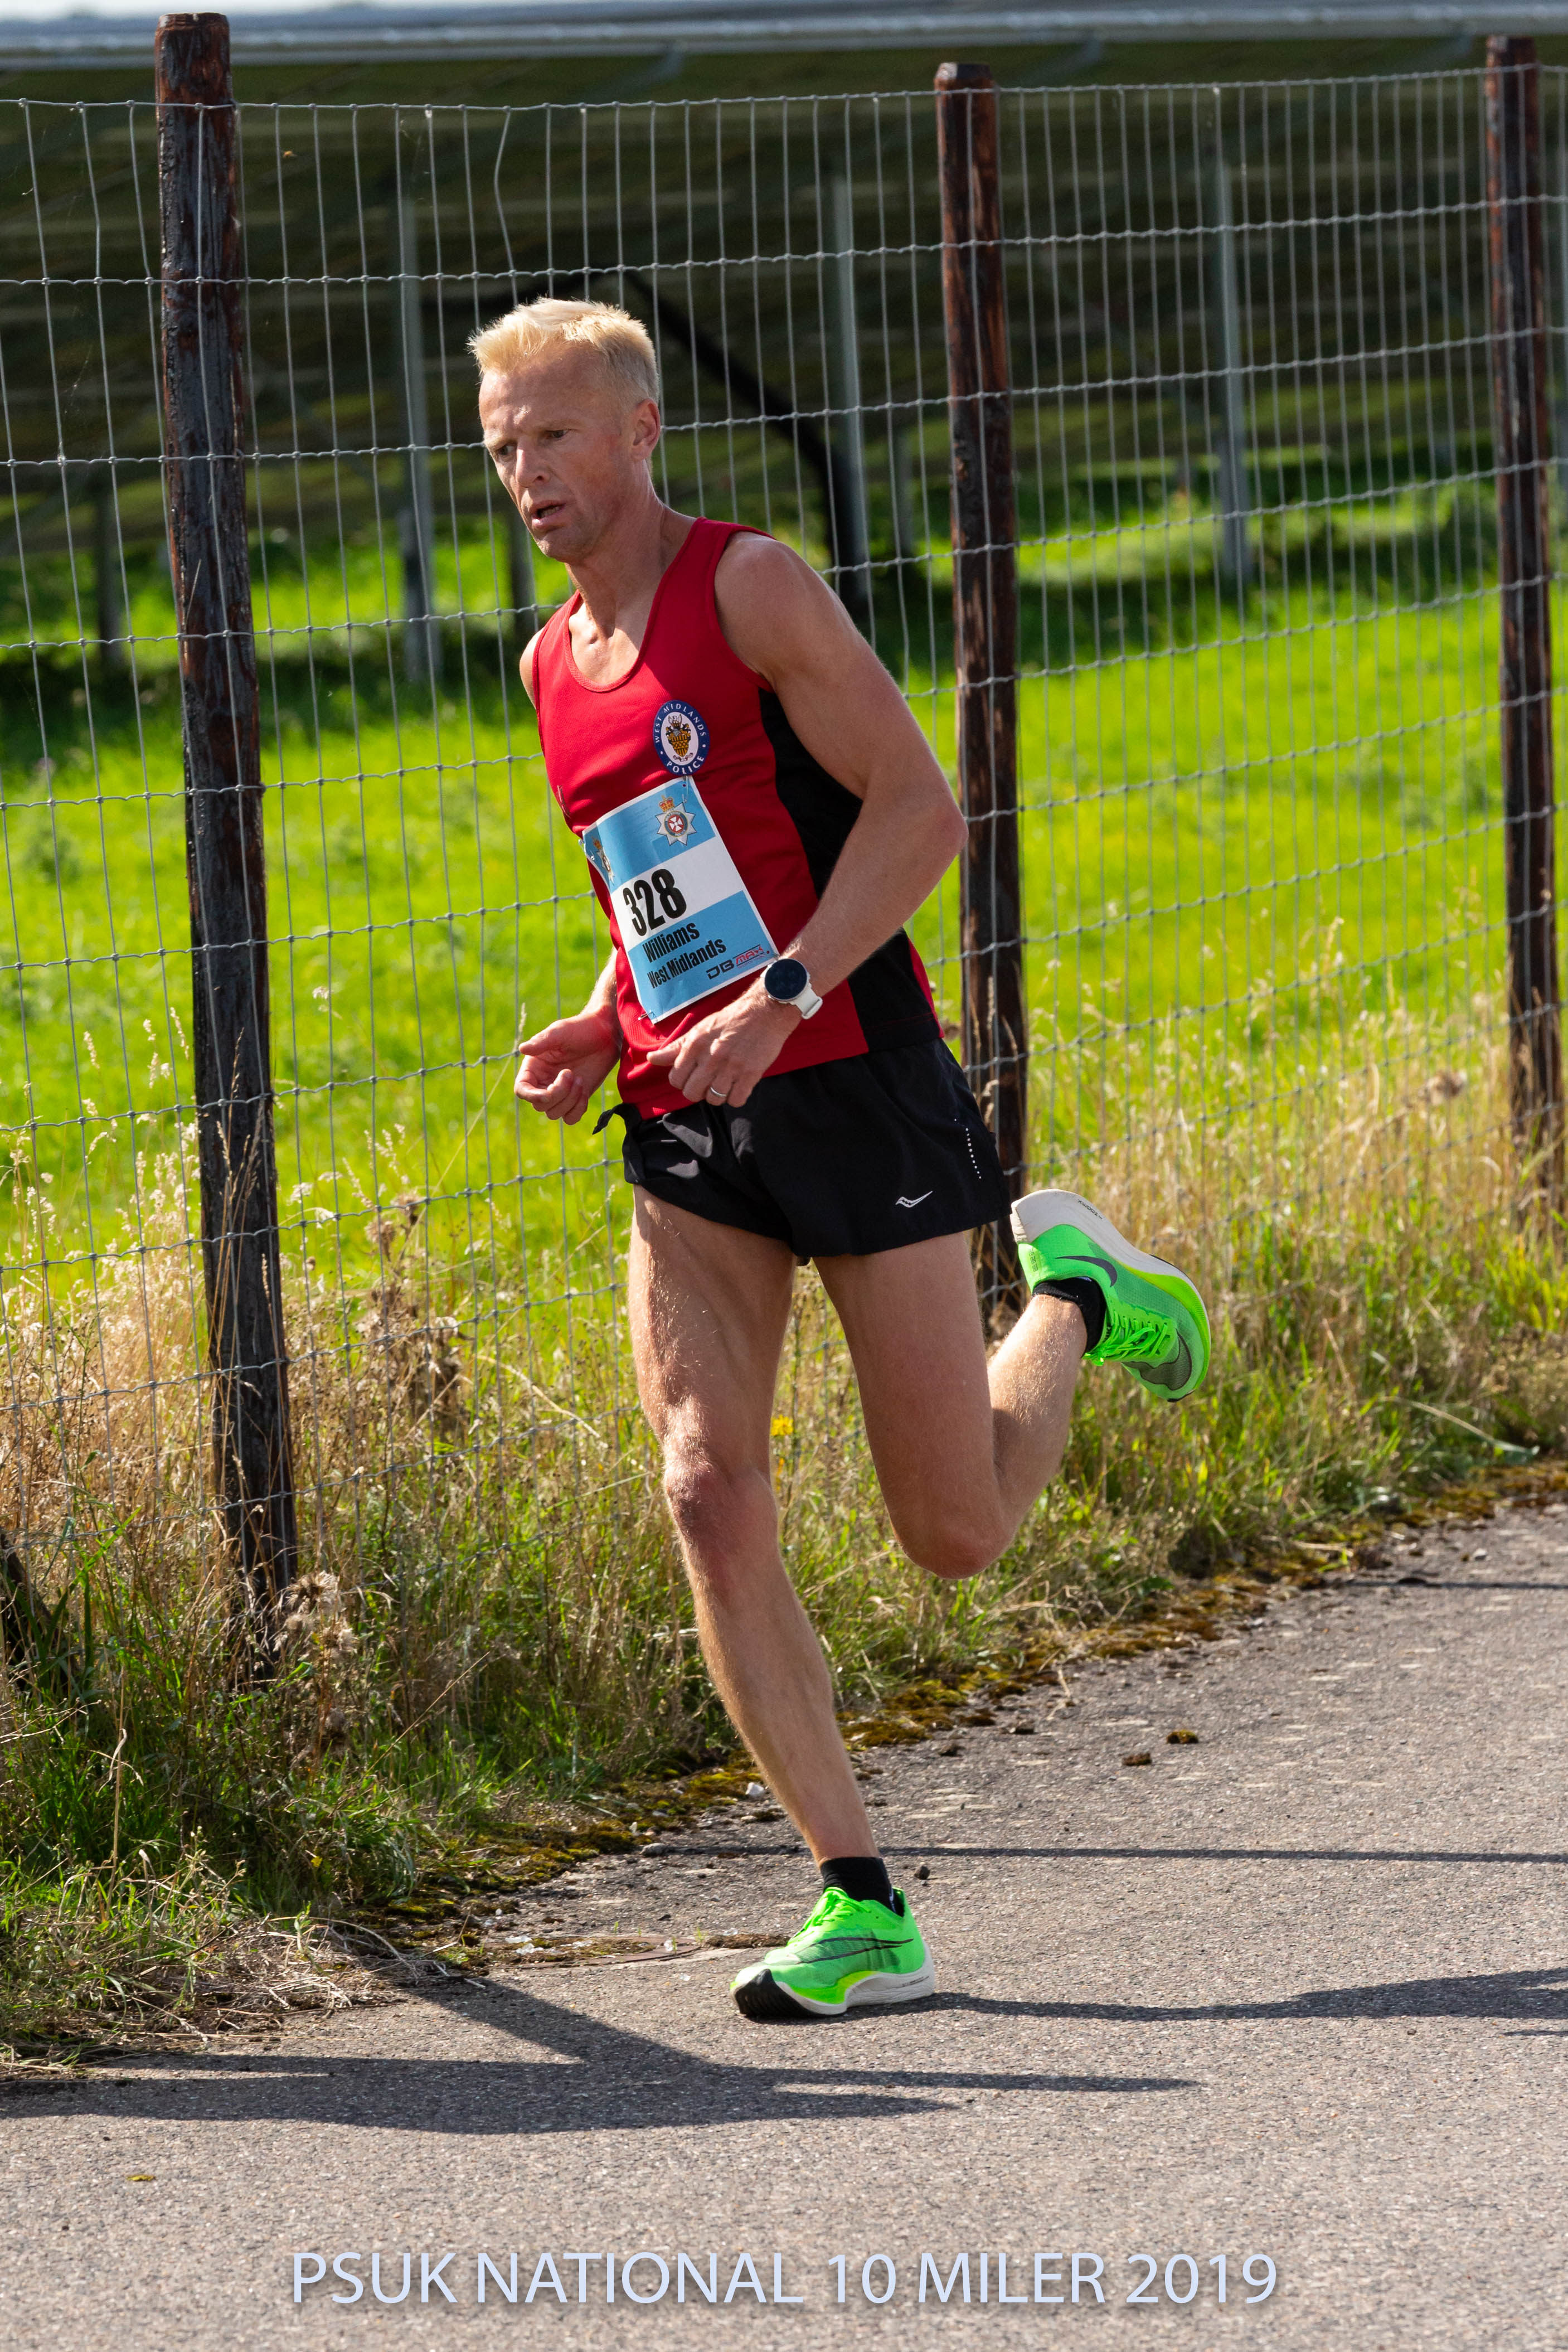
From the gun 2015 and 2016 PSUK 10 Mile Road Race Champions, Martin Williams (V) (West Midlands) and local lad Ben Brewster (Wiltshire), respectively, took control of the race chased by Andy Miles (Cheshire), Paul Cardy (Hampshire), Matt Speed (Metropolitan)and the rest of the field. At the end of the first lap Williams was in control of the race having pulled away from Brewster and ran strongly to regain the title in a time of 54:41. Brewster finished second in a time of 56:08 and in doing so, led the host force to the Minor Forces Team award. Miles completed the podium by finishing third in 56:25.
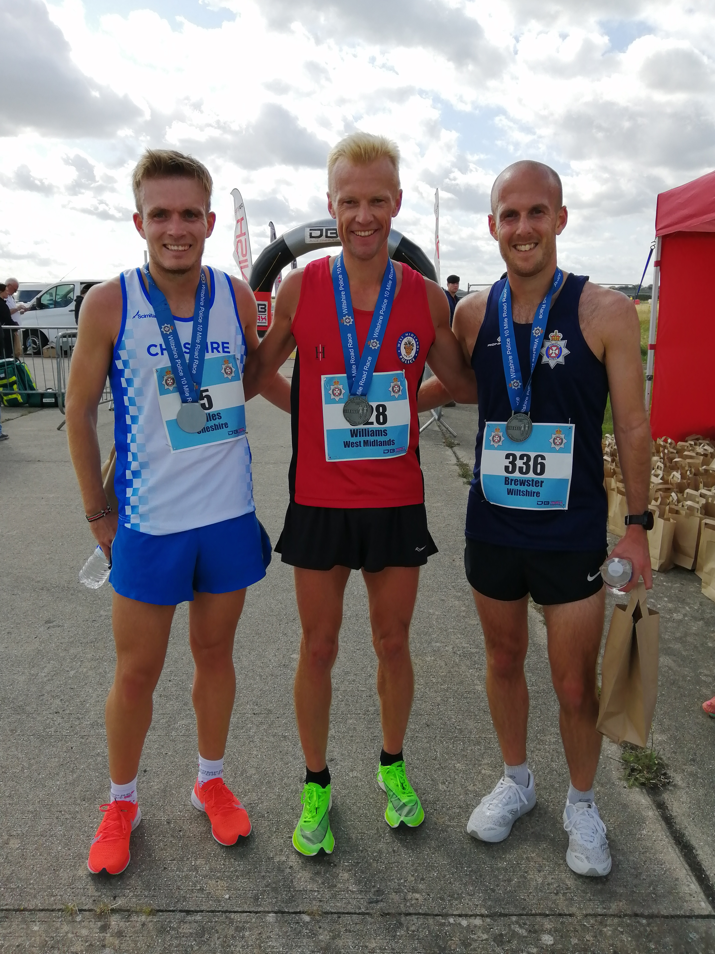

James Brannigan (V40)(PSNI) finished 11th , winning the Vet 40 category and also leading the PSNI team to both the overall team and veterans team awards.
The host force, Wiltshire won the Minor Forces Team award.
Other strong performances came from Rob Grantham (V45) (Cheshire), Scott Lynch (V50) (Kent), Darren Riley (V55)(Cambridgeshire) and Pete Orme (V60+) (Derbyshire) all who won their respective age groups.

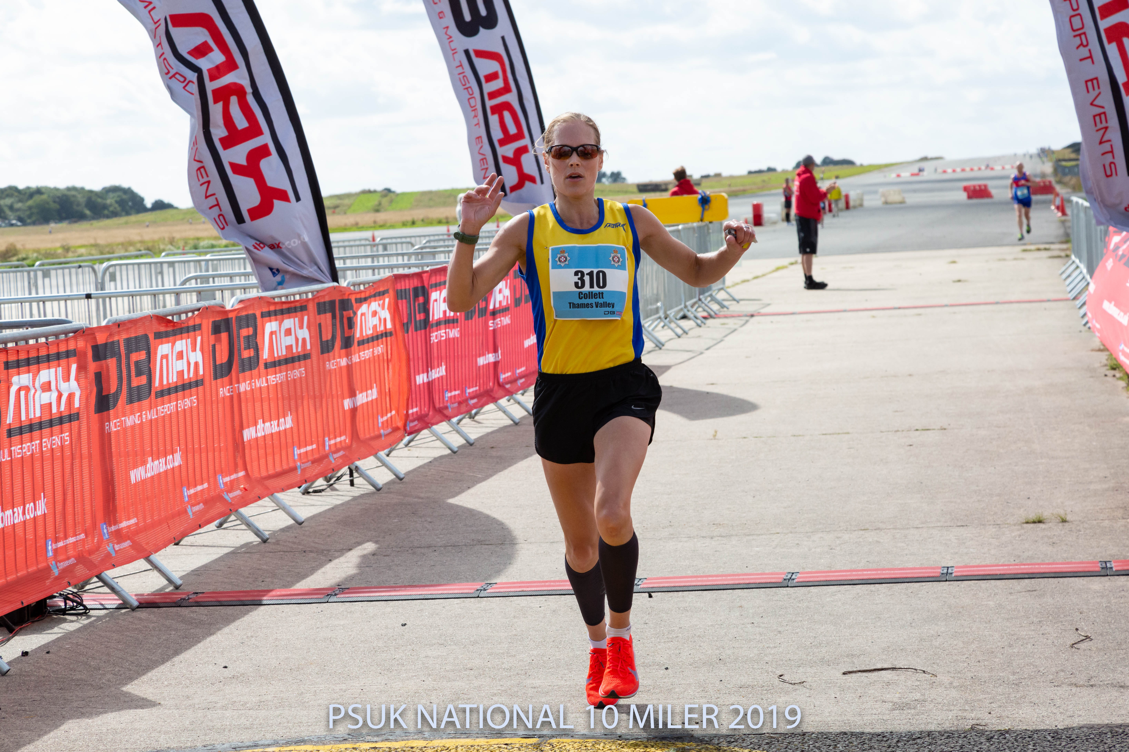
In the ladies race, Jill Collett (V)(Thames Valley) took control of the race from the gun and was never challenged taking her first PSUK 10 Mile Road Race Championship title and the overall veterans award, in 1:00:24.
Last year's champion, Sarah Hill (V)(Hampshire)was two minutes and twelve seconds down, in second place, leading the ladies Hampshire team to both the Overall and Veteran ladies team awards.
Helen King (V40)(Northumbria) , again,completed the podium in 3rd in a time of 1:06:05. All medal winners chose to take the overall prize awards instead of their veteran age group categories.
North Wales Police won the Minor Forces Ladies Team award – The Griffin Trophy.
Other strong performances came from Julie McArthur (V35) (Staffordshire), Kelly Morgan (V40) (South Wales), Ann Gallon (V45) (Police Scotland), Cathy Bruneau (V50) (Suffolk) and Veronica Lawley(V55+) (Hertfordshire) all who won their respective age groups.
All competitors are to be congratulated on their efforts and the organisers on a well organised and successful championship.

POLICE SPORT UK 10 MILE ROAD RACE CHAMPIONSHIPS

MOD Lyneham, Wiltshire.
Wednesday 4th September 2019
RESULTS

MEN’S RACE
1st | Martin Williams (V) | 54:41:00 | West Midlands
2nd | Ben Brewster | 56:08:00 | Wiltshire
3rd | Andy Miles | 56:25:00 | Cheshire

VET 40
1st | James Brannigan | 01:00:07 | PSNI
2nd | Andrew Proctor | 01:00:34 | Hampshire
3rd Darren Hamilton 01:02:24 PSNI
Vet 45
1st Rob Grantham 59:18:00 Cheshire
Vet 50
1st Scott Lynch | 01:06:46 | Kent
Vet 55
1st Darren Riley 01:05:34 Cambridgeshire
Vet 60
1st Pete Orme 01:09:41 Derbyshire
WOMEN’S RACE
1st | Jill Collett (V) | 1:00:14 | Thames Valley Police
2nd | Sarah Hill (V45) | 1:07:43 | Hampshire
3rd | Helen King (V40) | 1:08:37 | Northumbria

VET’S 35
1ST Julie McArthur 01:12:18 Staffordshire
2nd Sarah Stephens 01:16:30 Metropolitan
3rd Alisa Currie 01:18:45 Police Scotland
Vet 40
1st Kelly Morgan 01:09:18 South Wales
Vet 45
1st Ann Gallon 01:10:52 Police Scotland
Vet 50
1st Cathy Bruneau 01:12:04 Suffolk
Vet 55
1st Veronica Lawley 01:23:08 Hertfordshire

Team Results
Ladies Men’s
1st Hampshire (2+13+15) = 30 1st PSNI (11+19+20+23) = 73
2nd Police Scotland (7+8+20) = 35 2nd Cheshire (3+7+26+39) = 75
3rd South Wales (6+16+18) = 40 3rd Wiltshire (2+9+17+51) = 79

Veterans

1st Hampshire (2+13+15) = 30 1st PSNI (11+20+31) = 62

Minor Forces

1st North Wales 1st Wiltshire

