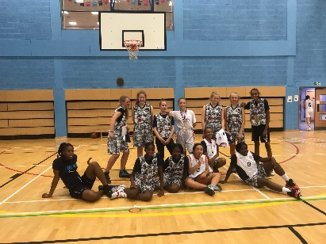
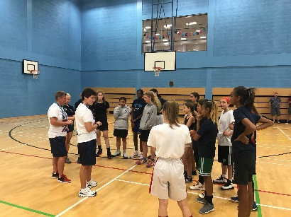
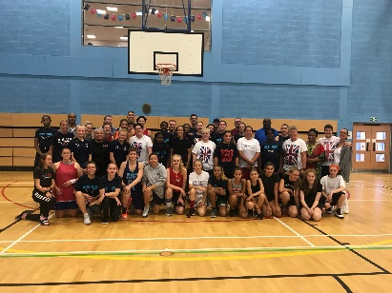
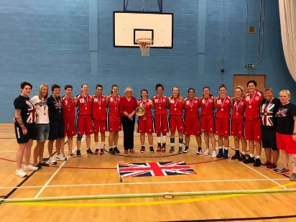
GB Police Woman’s Basketball Squad

Police GB / YBL / Aspire
  - Rugby September 2019

The GB Police Women’s team came together between 13th – 15th September 2019 for their first of 3 training camps prior to the UPSE Championships which are going to be UK hosted between 20th and 26th July 2020 in Worcester.
The championships will see them face tough competition from six European Police teams all fighting for the coveted title.

The squad is represented by police officers and police staff from several different police forces throughout England and Scotland. The weekend training sessions are a really important weekend in preparing for the Championships. The sessions give the coaches opportunity to look at selecting the best team to face the European opposition, a chance for the team to develop skills, fitness and gameplay.

It’s where it starts
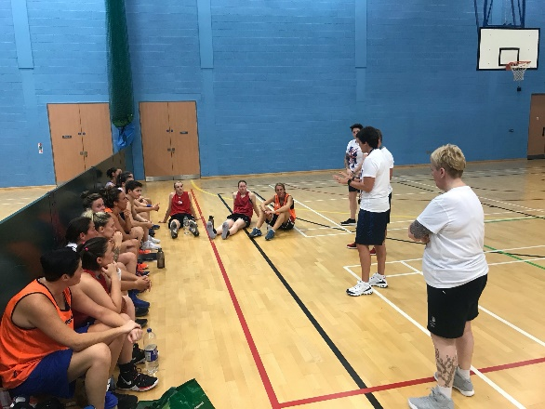
Sally Bunyard-Spiers and her team talking with squad
The players use the sessions to develop personally, as a team and the sessions are great for both their physical health and mental wellbeing. The girls stay in touch throughout the season over chat groups and social media to keep each other updated on progress injuries etc the squad recognise that it’s good to talk things through to motivate, help and support each other.  The squad’s head coach is Warwickshire Inspector Sally Bunyard-Spiers who has an accomplished basketball background at both junior and senior level. (England Jnr, Welsh Senior International, GB Olympian). She is assisted by DC Sarah Westgate from Norfolk Constabulary. Together they have been coaching the team for several years including at previous International European tournaments.  This season the team have been joined by Head Physio PC Laura Daly from Police Scotland who is working with each of the players on their personal fitness as well as putting individual plans in place for recovery from injuries. It is an exciting time for the team having this new role within the team to have an expert at the sessions to help will hopefully cut down on future injuries and help players along with their recovery process. |  | Running through offensive and defensive plays  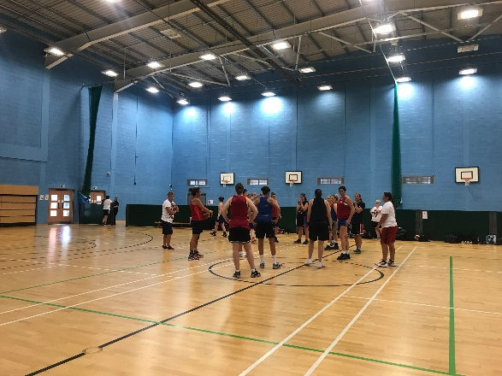

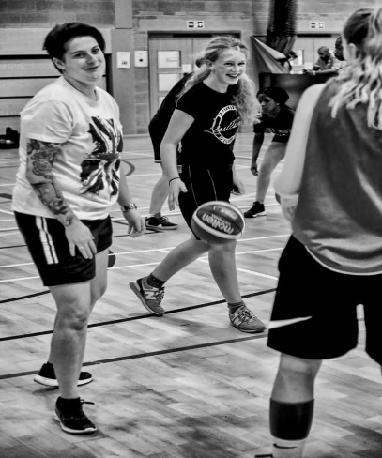  Laura Daly running her warm up session  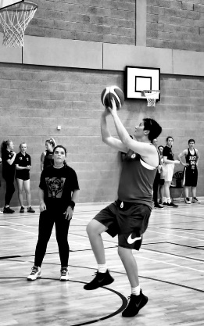  Shooting practice.  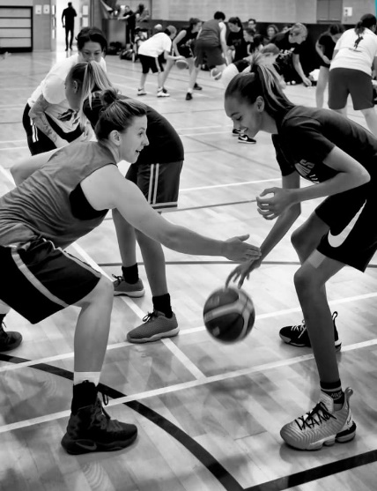  Ball handling drills  Barry Bunyard Inter-Association Plate  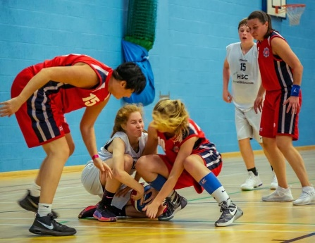  Strong competition but a great game  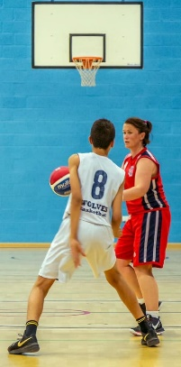  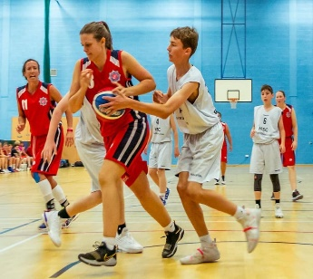  Rugby Training Squad  PC Deborah Archibald - Police Scotland  Heather Cosgrove - Police Scotland  Clare Duddy - Police Scotland  Lou Gibson - Leicestershire Police  Amanda Johnston - Police Scotland  Claudette Jordan - West Midlands Police  Louise McInnes - Police Scotland  Lee-Anne Mulholland - Police Scotland  Hannah Nethercot - Leicestershire Police  Stacey Townsend - West Midlands Police  Joanne Ward - West Midlands Police  Cara Wilcock - Leicestershire Police  Gemma Randles - Devon and Cornwall Police  Unable to attend  PC Tracy Allan - Police Scotland  Lynne Cochrane - Police Scotland  Lisa Coffey - Wiltshire Police  Juliet Faram - South Yorkshire Police  Susanne Fleming - Police Scotland  Ashley Matthews - Police Scotland  Carrie Stewart – Police Scotland |  | Community Engagement  Girls from YBL (Youth Basketball League C.I.C) and Basketball England ‘Aspire’ Programme were invited to a two hour training session run by the GB coaches, firstly the girls were put through a rigorous warm up and stretching session run by new Head Physio Laura. The team wanted the girls to understand the importance of getting yourself both physically and mentally ready for training and games.  Girls need positive role models, and the session allowed them to see that Policing as an employer gives opportunities to continue to participate in sport at a high level. They also spoke with the GB players about the pathways they had taken through education into employment still playing basketball.  Next the girls were put through their paces by Sally and her assistant coach Sarah, before the GB women joined them and they were all put through their paces.  This was not only an opportunity to learn new skills and drills but it was also a fun way for them all to interact.  It was great to see the team working with the visiting junior players, it was evident that they all enjoyed the session which worked on fundamental skills, shooting and gameplay  The session was a huge success with the GB Management Team getting feedback and comments from the junior girls that “it had been a great session”, “the police were really nice”, “it was a once in a lifetime experience”, “when can we do it again” and “thank you for letting us train with you”.  The event was also attended by Police Community Support Officers from Warwickshire Police who also spoke with the girls and their parents offering advice and crime prevention leaflets as well as reflective back pack strap covers for the approaching dark nights.  Some of the girls took the opportunity to stay a little longer and be involved in a scrimmage game.  In whole the session was a great success, allowing young girls currently playing to see that there is a pathway from playing basketball at school, in local league, national league, Apsire, college, university and employment. Policing recognises the importance of the mental and physical wellbeing of its staff and supports their involvement in sport to achieve this.  Sally Bunyard-Spiers said "both Sarah and I thoroughly enjoyed the opportunity to work with the junior girls. It is so important to encourage young girls to be active in sport, not only for their health and wellbeing, but also to have an opportunity to represent their country at the highest level". In whole the session was a great success, allowing young girls currently playing to see that there is a pathway from playing basketball at school, in local league, national league, Apsire, college, university and employment. Policing recognises the importance of the mental and physical wellbeing of its staff and supports their involvement in sport to achieve this.  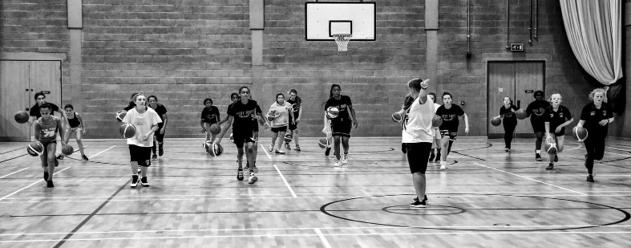  Sarah Westgate doing some drills with junior girls  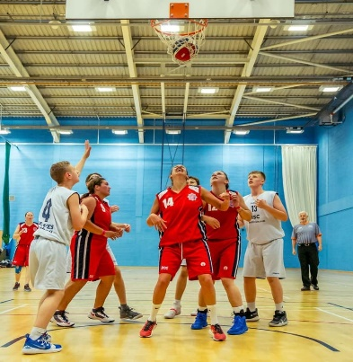  During each of the team’s training camp a local team will be invited to play for the Barry Bunyard Inter-Association Plate which is named in honour of Sally’s father.  On Sunday the GB squad faced some strong competition from one of Worcester Wolves Basketball Academy’s National League teams. This was a great game for both teams as the squad were going to be entering their first season at National League and it gave the GB team opportunity to try out new offenses and defences and play different team combinations.  Again it gave the team opportunity to interact with a junior squad, using sport as a tool to engage with young people in our local communities.  Both teams wanted to win, but the GB team played strong and consistently taking the lead and holding a good 16 point lead in the end. Final score was GB Police 50 Worcester Wolves 34.  Congratulations to the GB Women's Police Team for winning the Barry Bunyard Inter-Association Plate for 2019.  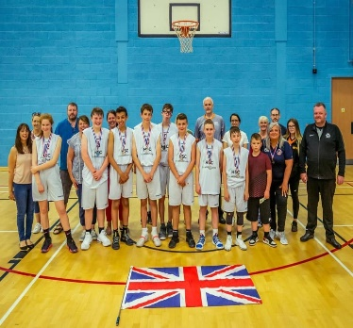  Management Team  Sally Bunyard-Spiers - Warwickshire Police  Sarah Westgate - Norfolk Constabulary  Ann Marie Stobo - Retired Police Scotland  Kim Humphreys - Retired West Midlands Police  Laura Daly - Police Scotland

