PSUK NETBALL SECTION
KNOCKOUT CUP FINALS
PLATE FINALS
Wednesday 19th June 2019
Nottingham Trent University

The knockout and Plate finals were held at Nottingham Trent University Lee Westwood Sports Centre at Clifton in Nottingham on Wednesday 19th June.

Both matches were highly contested. A great showcase for Netball.
However, the Knockout final went into extra time and the teams could not be separated until the dying seconds with Lancashire Police getting win by one goal.

KNOCKOUT FINAL
Lancs 50 - Metropolitan 49

WINNERS LANCASHIRE
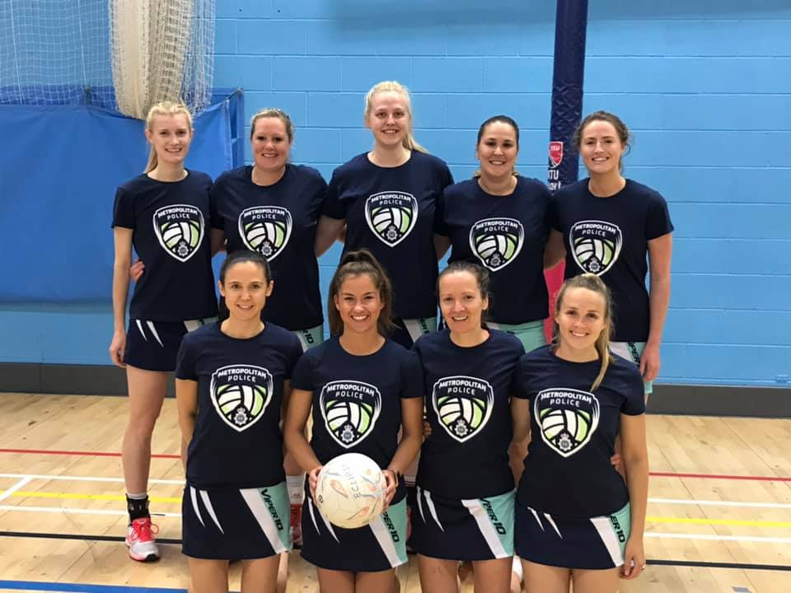
RUNNERS UP METROPOLITAN

PLATE FINAL
Cambridgeshire 49 – Cheshire 41

WINNERS CAMBRIDGESHIRE
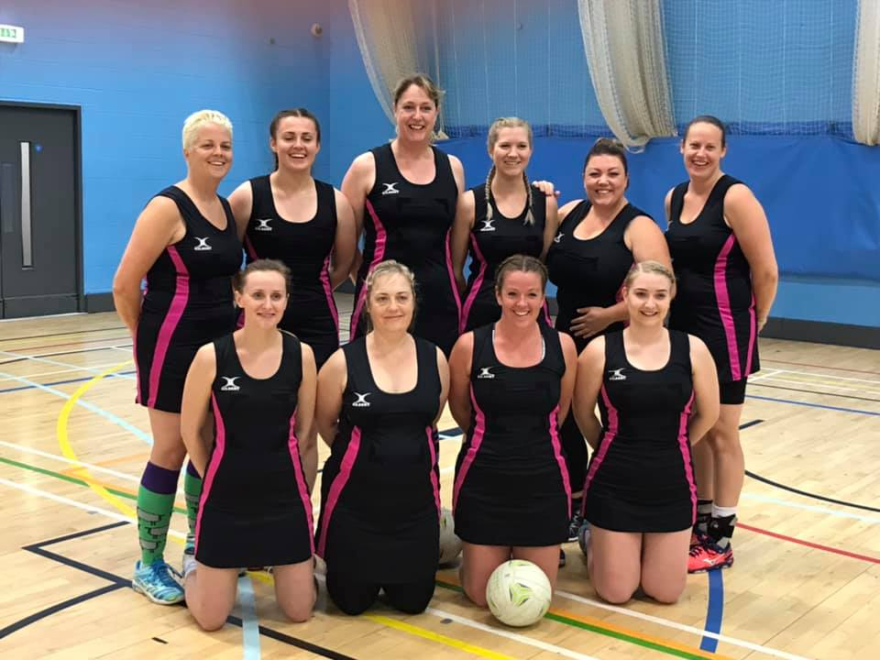

RUNNERS UP CHESHIRE
