United Kingdom Police Football team retain the Staffordshire Bell Trophy
UK Police played the UK Fire Service at Braintree F.C yesterday in what proved to be a tightly fought match. The Police had a number of opportunities in the first half to take the lead, hitting the crossbar twice. However, they were lucky to go in level at half time with the Fire Service creating two good chances just before the break. The second half started as the first with the police having the larger share of possession but being unable to convert a number of chances including hitting the crossbar a further three times.
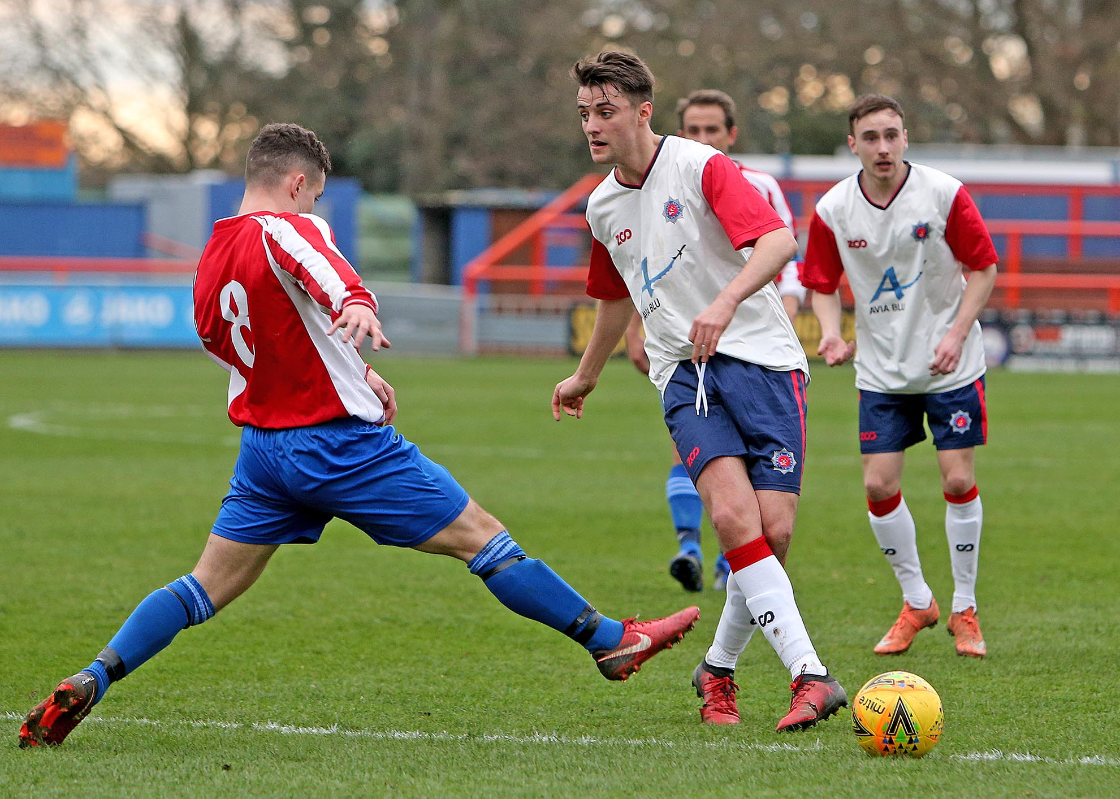
On 60 minutes following a free kick and a corner, the Fire Service took the lead with a neatly placed header from a 2nd corner to the right hand side of the goal. This seemed to wake the Police team who then created numerous chances but were unable to convert due to resolute defending by the Fire Service. On 80 minutes the Police finally scored with deflected shot from outside the box.
The final 10 minutes saw both teams create further chances however the final whistle saw the game level at 1-1.
Penalties followed with Police scoring all 5 and the fire Service missing one.

Result:
UK Police 1 – 1 Fire Service (after 90 minutes)
UK Police won 5 – 4 on penalties
As ever thanks to our Sponsors – iCore Ltd and Secured by Design.
Greg Lake from iCore was in attendance and awarded the man of match trophy to Steve Gordon of the Police.
Brad Howe, Secretary.

