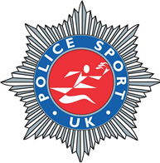
PSUK EQUESTRIAN TRAINING ACADEMY
INTERNATIONAL SHOWJUMPER & COACH
PAUL CRAGO
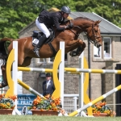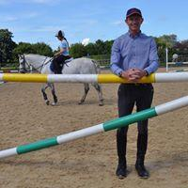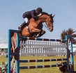
P.S.U.K. EQUESTRIAN ARE DELIGHTED TO ANNOUNCE OUR SHOWJUMPING AMBASSADOR AND OFFICIAL TRAINING COACH
Paul Crago is a successful international show jumper with a reputation for producing quality horses from novice to international level. He has been a GB Nations Cup member on several occasions and has competed with great success across Europe and the UK including London Olympia, HOYS and RIHS. Paul always has a quality selection of show jumpers, dressage and event horses for sale, they are produced with patience and attention to detail with his wife Karen who is herself a talented dressage rider.
Coaching on a group or individual basis is a big part of Paul’s professional life along with his role as a UKCC Coach Educator and Assessor for British Show Jumping. Paul coaches all over the UK and Channel Islands and is very much involved with Junior and Senior academies in Wales, Jersey and Berkshire.
Paul Crago: “I am very much looking forward to my partnership with Police Sports U.K. to support your members with their personal goals and also achieve their very best in equestrian competition.” January 2019
U.K CLINIC DATES & REGIONAL TEAM TRAINING AVAILABLE

